**1. Business Metrics (Third Week)**

As a business analyst, it is important to analyze and convey your company's performance using specific metrics in each of the following areas:

* Marketing
* Growth
* Sales
* Finance

This lesson focus on metrics that are commonly used across industries and a wide range of business roles. At a high level, these metrics are related to the sales, finances, customers, and website.

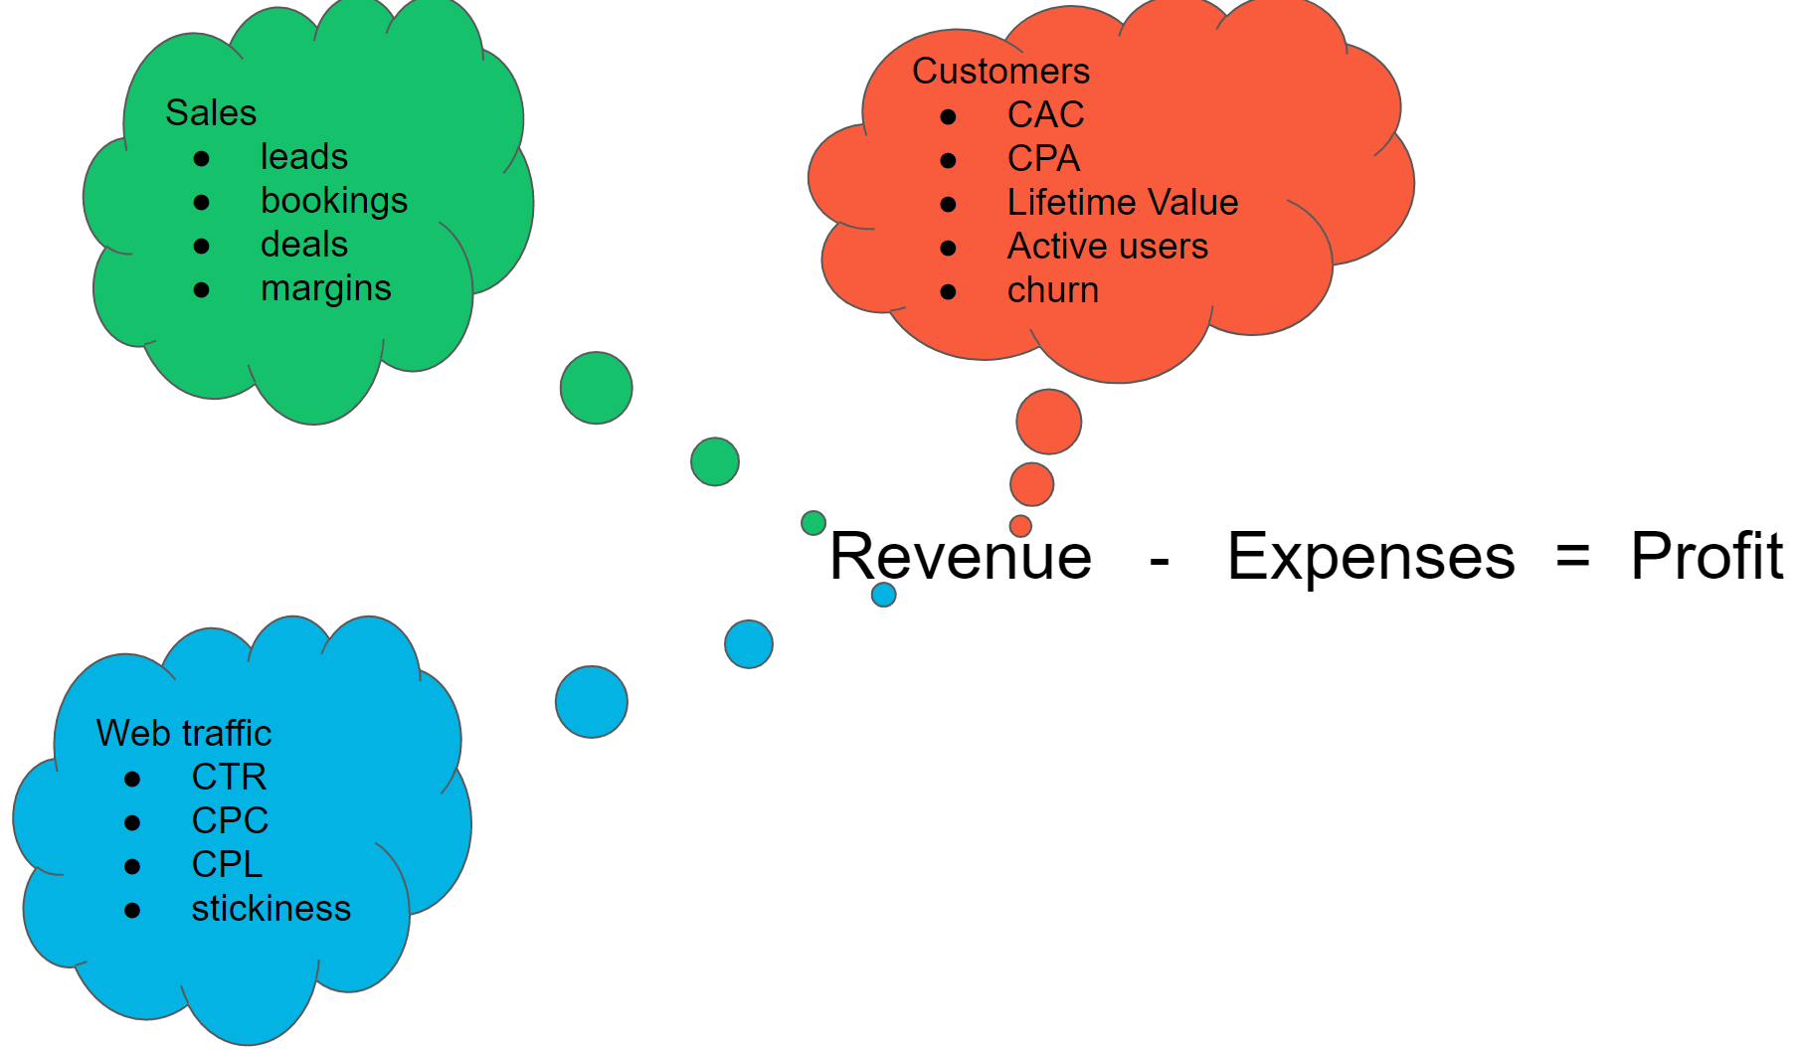

Business metrics related to finances, customers, and website

# Key Performance Indicators

Businesses need to be able to track how they are performing on key goals or objectives - whether they are growing number of customers, bringing down their costs, increasing revenue on an ongoing basis, and myriad others. **Key Performance Indicators** or **KPIs** are how they measure their success on each of their key business objectives.

## Which KPI to use?

The decision regarding which KPI a business analyst should use depends on several factors, including which industry or domain they are working in, which business function they are focusing on, and the type of data they have available to them.

## Asking Data Questions

The KPIs you use will be determined by the questions you need to ask. As a business analyst, you are tasked with gathering the appropriate data to help solve business problems. To get to that solution, you will need to:

* Identify what needs to change
* Communicate this change to stakeholders in clear manageable chunks of data

### How to Ask the Questions

There are several steps needed to determine the questions to ask—

1. Identify the business goal and objectives.
2. Narrow down the type of data needed to answer questions.
3. Identify the KPIs that will be useful to show whether you are making progress on your business goal.
4. Conduct the data analysis using the KPIs and use visualizations as part of the analysis.
5. Provide recommendations and findings based on the completed data analysis.
6. Create succinct and visual presentations for the stakeholders.

## Business Process Flow

To understand business metrics, you first need to understand a typical business cycle so you know where to use the metric. So let’s first understand that.

A business has two primary goals:

1. **Increase revenues**
2. **Reduce costs**

Metrics allows businesses to assess whether they are on track to meet these goals. In the WeCart example, the business executives need to think about the costs related to

* Building
* Promoting
* Operating

their business and the different ways to increase revenue.

|  |  |  |
| --- | --- | --- |
| **WeCart Business Goals** |  |  |
| **Reduce Costs** |  | **Increase Revenue** |
| Website & Engineering |  | New Customers |
| Staff Salaries |  | Marketing |
| Supplies & Payment System |  |  |
| Legal Contracts |  |  |
| Rent |  |  |

# Business Process Flow: Marketing

There are some typical costs involved in the marketing process. Marketing teams incur these costs as they think about how to market their product to their customers.

Marketing is about **how** and **where** you get the word out about your product. Traditionally, there were just three channels to do:

1. Newspapers
2. Radio
3. Television

However now, the internet makes marketing and advertising possibilities limitless and companies use a variety of social media platforms to market such as

* Instagram
* Twitter
* Facebook
* Google Search
* Linked In
* blogs

Online marketing can take advantage of **cookie tracking**, which allows customer tracking across time and platforms.

Knowing a customer's online roadmap enables companies to pinpoint places for targeted advertising to these customers and other potential customers like them.

## Business Process Flow: Growth

What are typical questions business analysts try to answer when they are considering issues of a company's growth? To grow the business, companies need to not only focus on existing customers, but also on new customers. This problem is at the heart of the growth metric. Executive boards, investors, and sales teams are constantly keeping their eye on this critical question about a company's overall health.

Let's continue with our WeCart example to broadly discuss the business question of growth. One of the questions the company's executives have is, "How can the company grow its customer base?". WeCart can grow in two ways:

1. **Increase new customers**
2. **Increase the order size and repeated orders of existing customer**

As a business analyst, you need to break down the question of business growth to decide how to quantify or measure the answer for the growth question.

# Customer Journey

How can WeCart track a customer's online path to and through their website?

For WeCart, tracking customers through online spaces can take several steps:

* WeCart can identify specific ad platforms, like search engines and social media sites, to quantify how many people see its ads.
* When people click on WeCart's ads, they go directly to WeCart's site and a **cookie**is placed on the viewer's browser. **Cookies** allow a company to track what site visitors do on its website.
* The business goal for site visitors may be for visitors to engage with a prompted **call to action** on the website; for example, giving an email address or downloading a brochure.
* If a visitor, now a potential customer, adds something to a cart, cookies begin tracking their path to becoming a paid WeCart customer.

The visitor/customer journey described above can be described as 5 stages in which marketing teams used various digital tools to attract potential customers and convert them into actual customers. :

1. **Awareness**
2. **Interest**
3. **Desire**
4. **Purchase**
5. **Post-purchase**

This journey can all be tracked along the **marketing funnel**, which will be discussed on the next page.

**New Vocabulary**

* **Call To Action (CTA)**: A marketing term that refers to an action a website visitor is supposed to take when given a specific prompt on a website. These can be words or phrases, or icons that prompt and encourage the user to perform the action.
* **Post-Purchase**: Actions customers take after purchasing an item that promotes and increase sales and advocate on behalf of the company. For e.g., coming back and purchasing more items, sharing or liking the company or product on social media, taking pictures of the item, and tagging it on Pinterest.

# Marketing Funnel

The **marketing funnel** is the process of tracking and analyzing each step of the customer journey with data.

## Marketing Funnel Metrics

**Impressions & Reach**– building brand and product awareness using ad platforms and search engine optimization (SEO). SEO allows ads to show up for the right mix of search terms as people search online

* **Impressions** – an instance of an advertisement appearing on a website when it is viewed by a visitor.

**Lead generation**– measures how many visits are made to the website.

* **Click –** every time a website visitor views the ad and clicks it
* **Click Thru Rate** – number of users that clicked an ad or clicked a link sent via email
* **Cost Per Click**
* **Cost Per Lead** – indicates a user has become a potential customer or **lead** because they have expressed interest in the company by downloading a document, creating an account, or providing an email address.

**Conversion**– when a lead converts to a paid customer

* **Customer Acquisition Cost**

## Two Additional Levels

Before we move on, I wanted to share 2 more measures that companies use.

### Loyalty

To grow their revenue and company profits, companies don’t just want their customers to buy once from them, but to come back to their website. Especially if the product is not a high-priced product. That customer loyalty allows you to track how many revisits a customer is making after their first purchase, or how many of the customers have continued shopping after their first purchase.

**Metrics:** Some commonly used metrics include **Repeat Purchase Rate** and **Net Promoter Score**. We will not be going in-depth with these, but please do check out the resources below to learn more about them.

### Advocacy

Another level companies sometimes track is whether their customer is advocating for their company. That is, saying good things about the product and services. Leaning on social media provides a great opportunity to do just that.

**Metrics:** Some commonly used metrics include **Customer Referrals** and **Leads from Social Media**. For example, as the paid customer tweets about the company, likes the product on FB, provides a good rating on Amazon or the company website, analysts can use those metrics, such as ratings and likes to show how many of the customers serve as advocates.

We will not be going in-depth with these last two stage levels, but we have provided some resources below to help you understand these more.

**New Vocabulary**

* **Search Engine Optimization (SEO)**: The goal of search engine optimization is to influence the frequency of a website appearing in response to specific search terms in a search engine. You can learn more about it on this [Wikipedia page](https://en.wikipedia.org/wiki/Search_engine_optimization) and this [Forbes article](https://www.forbes.com/sites/theyec/2020/03/27/the-10-commandments-of-seo/?sh=43e00e693e07).
* **Lead**: A potential customer interested in the products or services of a company.
* **Conversion**: When the lead (potential customer) purchases the products or services being sold by a company.
* **Repurchase Rate**: This [Medium blog](https://medium.com/@matsutton/repurchase-rate-the-most-overlooked-ecommerce-kpi-337bccde184b) describes how to calculate Repurchase Rate metrics.
* **Net Promoter Score**: This [Wikipedia page](https://en.wikipedia.org/wiki/Net_Promoter) describes the calculations and origin of NPS.

# Click Through Rate (CTR)

As potential customers view the ads, some of those potential customers will click the ad and be taken to the website for the company. To be counted at this level, the user needs to click through the ad and the metric we use here is **Click Through Rate**.

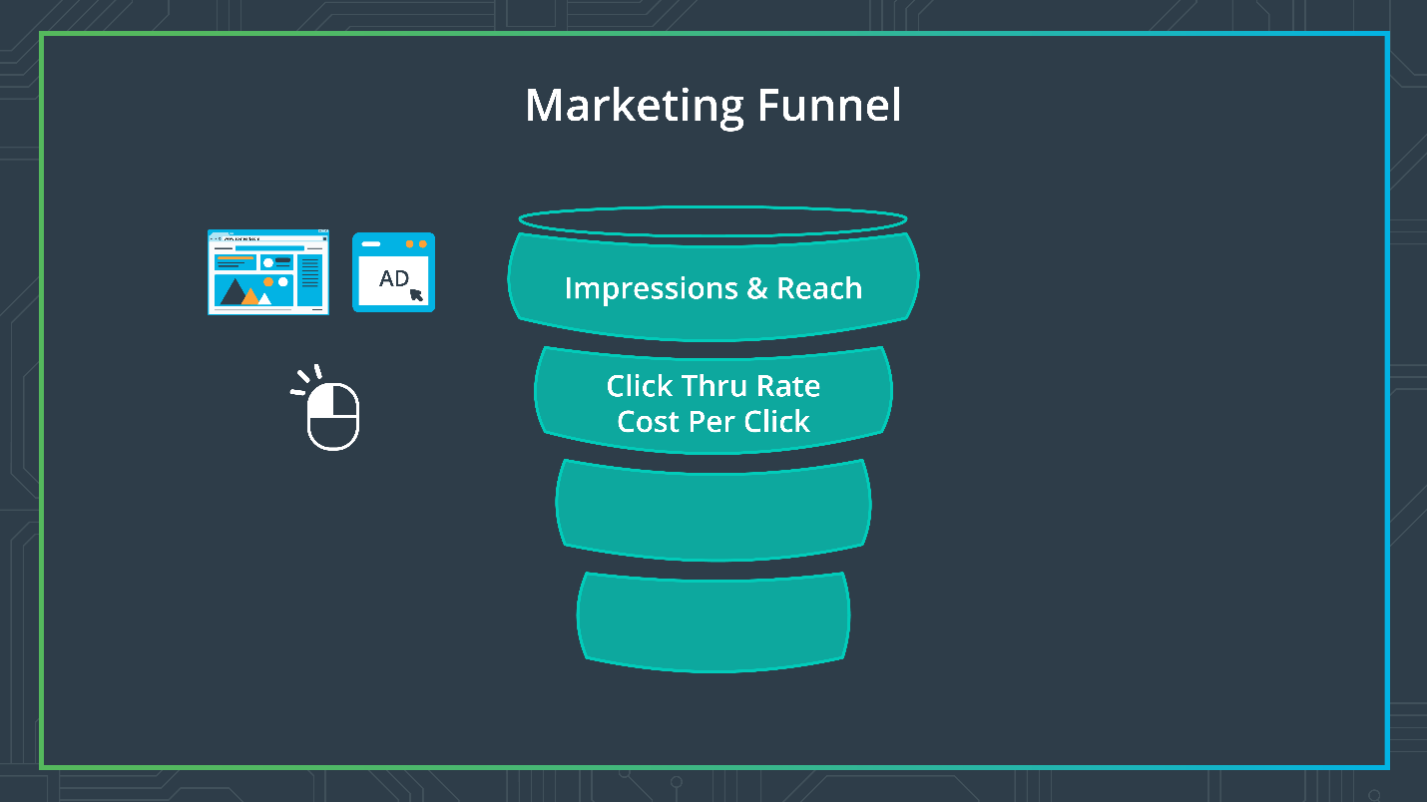

Marketing Funnel Click Through Rate

### Calculating WeCart's CTR

To Calculate WeCart's **Click Through Rate (CTR)** we need to calculate both the number of **impressions** and the number of **clicks**. If you remember from the previous page:

* **Impressions** – record an instance of an advertisement appearing on a website when it is viewed by a visitor. So if you visit the page 4 times, say in one hour, the gross impression count will include each repeated viewing.
* **Clicks –** every time a website visitor views the ad and clicks it, this gets included in the click count

The formula used to calculate CTR is: **Click Through Rate (CTR)** = (Clicks/ Impressions) * 100

**WeCart's CTR**

|  |  |  |  |
| --- | --- | --- | --- |
|  | **Impressions** | **Clicks** | **Click Through Rate (%)** |
| Facebook Ad | 1100 | 15 | 1.36 |
| Google Search | 2000 | 67 | 3.35 |
| Google Display | 1500 | 25 | 1.67 |

**Interpretation of CTR**

The Click Through Rate is an informative metric that informs your marketing team whether they should try and increase the number of impressions or when they should reword the ad to increase clicks. Remember, if a person clicks through the ad, it does not mean the customer purchased, but rather they are showing interest in what the ad is about. When your CTR is low, your ad campaign is not generating enough interest. When the CTR increases, it is an indicator of effective and interesting content in your ad campaign, and that maybe you should increase the number of impressions for that ad.

Some points to remember:

* **Click Through Rate (CTR)** is the ratio of users clicking on a link or an ad to the number of total users who received the link or saw the ad.
* CTR measures the success of an advertising or email campaign.
* When the CTR increases, it is an indicator of effective and interesting content in your ad campaign, and that maybe you should increase the number of impressions for that ad.
* In general, a 2% CTR is good, however, the rate will vary by industry.

# Cost Per Click

**Cost Per Click (CPC)**refers to the cost to get a click on your ad. It helps us gauge the cost of advertising on the specific platform, so we can see which platform is generating more leads.

Since platforms charge you for the number of ads on a page, you can compare the CPC for the different platforms you are advertising on and see which platform is generating more interactions with your website, or generating more traffic to your website.



Marketing funnel: Cost Per Click



### WeCart's CPC

|  |  |  |  |
| --- | --- | --- | --- |
| **Source_platform** | **Facebook Ad** | **Google Search** | **Google Display** |
| Spend | $1,500 | $3,000 | $5,000 |
| Clicks | 700 | 2,900 | 4,995 |
| **Cost Per Click (CPC)** | $2.14 | $1.03 | $1.00 |

## Interpretation of CPC

CPC is an indicator of the cost-effectiveness of the ad platform and a useful tool to compare and strategize about which marketing platform is yielding a higher impression and reach and resulting in potential leads.

Different ad platforms cost differently and it is important to remember that while one platform might be cheaper it may not necessarily deliver you as many potential customers as another platform. This is an important trade-off that analysts and marketing teams have to consider.

Some marketing channels or platforms convert amazing results but they are small and may not generate as many customers. While you may decide to continue using them, you will also need to identify marketing channels that deliver more potential leads.

# Cost Per Lead

Remember, **a lead is when a potential customer visits your website and does something on the website in response to a prompt**, such as share their email , or download a document, create an account. Once the viewer takes that action, we know the viewer is showing some interest for the product or service, and this could possibly lead to a sale. **With Cost Per Lead we are tracking whether the potential customer turned into a lead within a given time period, that could be a 30-day window or 60-day window.**

Let’s go back to our funnel - we are tracking how much did it cost us to get the potential customer to take that action on the website. We are calculating the cost of generating interest and nurturing the interest of the potential customer and figuring out how much did it cost us to get them to get to this level? The metric we calculate is the Cost Per Lead.

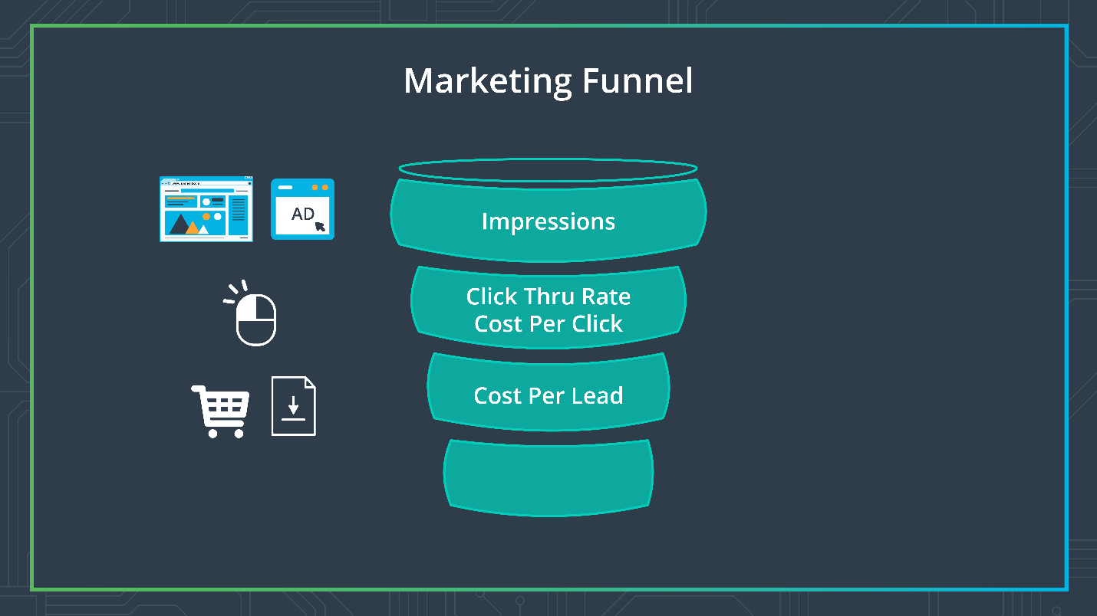

Marketing funnel: Cost Per Lead

The formula used to calculate CPL is:

### WeCart's CPC

|  |  |  |  |
| --- | --- | --- | --- |
| **Source_platform** | **Facebook Ad** | **Google Search** | **Google Display** |
| Spend | $1,500 | $3,000 | $5,000 |
| Clicks | 700 | 2,900 | 4,995 |
| Cost Per Click (CPC) | $2.14 | $1.03 | $1.00 |
| Leads | 16 | 63 | 112 |
| **Cost Per Lead (CPL)** | $93.75 | $47.62 | $44.64 |

## Interpretation of CPL

CPL is an indicator of the cost-effectiveness of the ad platform and a useful tool to compare and strategize about which marketing platforms yielded more leads. A low cost per lead means more of this particular type of person is likely to be interested in the product.

Looking at the data above, we can see that Google Display and Google Ads were comparable in terms of the Cost Per Lead. On the other hand, Facebook was costing us more to get to our potential customers.

At the same time, Facebook also generated fewer clicks, so we need to consider if we need to tweak the ad for the Facebook platform or consider other platforms that can generate the same or higher number of clicks for a comparable price.

## Customer Acquisition Cost (CAC)

Customer Acquisition Cost (CAC) is the metric used in the last step of the marketing funnel and tells us what the cost is to acquire a paying customer.

### Calculating CAC – Method #1

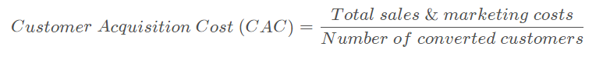

This is the point where a lead, or potential customer, has become a customer by buying something on the website (a product or service). Most companies try to get that number under 25%.

The ultimate goal is to increase the lead-to-customer conversions at the bottom of the funnel. Considering the fact that customer shopping cart abandonment is over 60%, each company's goal is to get higher levels of conversions for the minimum cost of sales and marketing. This leads to the concept of **optimizing the marketing funnel**.

**WeCart's CAC**

|  |  |  |  |
| --- | --- | --- | --- |
|  | **August** | **September** | **October** |
| Marketing Costs | $9,500 | $12,000 | $5,000 |
| Sales & Marketing Salaries | $25,000 | $25,000 | $25,000 |
| Overhead costs for Sales and Marketing | $10,000 | $8,000 | $8,000 |
| **Total Sales & Marketing Costs** | **$44,500** | **$45,000** | **$38,500** |
| Number of Paid Customers | 300 | 325 | 350 |
| **Customer Acquisition Cost (CAC)** | **$148.33** | **$138.46** | **$110.00** |

## Calculating CAC – Method #2

Sometimes it takes a long time for a lead to convert to a customer. For example:

* A lead may sign up for a free account or download for a few months and then be prompted to become a paying customer then.
* A marketing campaign may intentionally take some time to realize the revenues it is trying to generate.

To account for this 'lag' in revenue, CAC is often calculated based on a company's **average sales cycle. (\***averaged across the targeted time period**\* )**



**WeCart's CAC**

|  |  |  |  |
| --- | --- | --- | --- |
|  | **August** | **September** | **October** |
| Marketing Costs | $9,500 | $12,000 | $5,000 |
| Sales & Marketing Salaries | $25,000 | $25,000 | $25,000 |
| Overhead costs for Sales and Marketing | $10,000 | $8,000 | $8,000 |
| Number of Paid Customers | 300 | 325 | 350 |
| Weighted Average Costs (60 days/2 months) Prior & Current Month |  | 0.5(25,000+10,000)+ 0.5(25,000+8,000) | 0.5(25,000+10,000)+ 0.5(25,000+8,000) |
| **Customer Acquisition Cost (CAC)** | N/A | **$133.85** | **$129.29** |

I*n the example above for CAC is September, since we want to average between August and September, we take 1/2 of the expenses from August and 1/2 from September) and divide that by the # customers in Sept.*

**Interpreting CAC**

The CAC metric is an indicator of how much it costs to acquire a customer. If your customer service team is doing a good job of keeping the paid customers happy, that can lead to future leads and paying customers, and thus keep the cost of acquiring customers low. The company's goal is to keep the CAC low while increasing revenue, as this positively impacts the profit margin and profits.

Spending more than 25% of your revenues means you are spending too much to acquire new customers and spending less indicates that you are losing business opportunities.

**Recap**

* Customer Acquisition Cost (CAC) = (Total marketing expenses + total sales expenses and salaries)/ # of customers acquired
* The CAC formula can be modified with weighting for different months based on the length of the sale cycle.
* CAC is a useful metric used to get an estimate of how much it cost us to acquire the customer in the period the money was spent to reach out to them.

**Optimizing Marketing Funnel**

Optimizing the funnel requires identifying at what level of the funnel your customer loss is the greatest. In other words, are you losing the most customers at the awareness and interest age, or is it when you are converting them into leads?

* If you're losing many of them in the early stages of awareness, you need to focus on the types of ads you're creating, or the ad platforms you're choosing to reach your potential customers.
* If you're losing many of them at the conversion stage, you need to look at your website or online app. It's possible the site is not easy to navigate, and that's why not many customers are converting to paid customers.

So, essentially, you're calculating the success rate at getting a potential customer to do what you want them to do at each level of the marketing funnel, and you compare this number against your impressions.

**Conversion rates based on impressions**

Basically, at each touchpoint, we'll divide the number of people at each touchpoint divided by the total number of customers.

* 43 percent roughly of the people who saw the actual ad, downloaded the brochure
* 19 percent of the people who saw the actual ad arrived on the site, added items to the cart
* ~8 percent of the people who saw the actual ad actually purchased the item

**Conversion rates based on each touchpoint**

Another metric is to calculate the conversion rates based on *the Call to Action* at the previous level in the funnel, as opposed to the initial impression number as we did above.

So now we divide by the *number of people who actually took the call to action of the previous step.*

* 43 percent of that matches what's in the conversion rate based on the impression.
* 45 percent of those people who downloaded the brochure added their items to the cart.
* 39 percent of those people actually purchased the item.

|  |  |  |  |
| --- | --- | --- | --- |
| **Level** | **Numbers** | ***Conversion rates based on impression*** | **Conversion rates based on each level** |
| Arrived on site | 1000 |  |  |
| Downloaded brochure | 430 | 0.43 | 0.43 |
| Added item(s) to cart | 193 | 0.193 | 0.449 |
| Purchased item(s) | 75 | 0.075 | 0.389 |

*Conversion rates based on impressions = Numbers/Arrived on site Numbers

*Conversion rates based on each level = Current level Numbers/Prior Level Numbers

## Visualizations

This is a particularly useful tool when you want to engage the stakeholders, such as the executive team, around what the conversion rate data is telling us.

Line charts like this can allow you to indicate whether specific customer-facing tools and methods are showing a higher success rate in converting leads to paying customers.

This type of visualization allows the marketing and growth team to identify these successful tools and campaigns or failed ones as well, and plan future efforts to maximize conversions.

**Cost Per Acquisition (CPA)**

The impact of marketing campaigns can also be measured in terms of revenue using metrics that capture the financial cost.

* **CPA: cost per acquisition**
  + Focuses on sales and marketing costs, including the cost of supplies, labor, marketing, overhead, and sales that it took to convert a non-paying customer(called an acquisition) into a paying customer.

What is the difference between CPA and CAC?

* **CPA** – is focused on the marketing and sales cost, including overhead and salaries, with a focus on sales leads—not actual paying customers
* **CAC** – is focused on actual new customers who have made a purchase

**Recap:**

* Cost Per Acquisition (CPA) = (Marketing and Sales Cost)/ number of new leads customers
* CPA is referring to marketing + sales costs (overhead, salaries) in the numerator and includes only leads (non-paying customer) in the denominator.
* Here “acquisition” refers to a non-paying customer.

**Lifetime Value**

When deciding how to spend the marketing budget, you want to focus on some of your best customers – those that will stay for the long-term and continue to generate revenue for the company.

*These are your****high-value customers****and you want to bring in more of them.*

Your goal should be for every dollar spent on marketing efforts. It should provide a higher rate of return and generate revenue multiple times over.

Terms needed to calculate Lifetime Value:

**Purchase Cycle**: The time increment adopted for business calculations

* **Total Sale Revenue Per Cycle**: Revenue earned from a customer per purchase cycle
* **Number of Sales Per Purchase Cycle**: Number of times customer buys during the purchase cycle
* **Cost Per Acquisition**: (Cost of marketing and sales)/ number of new leads
* **Expected Retention Time**: Amount of time (measured in purchasing cycles) you expect to retain the customer.
* **Average Sale Revenue**: (Total customer revenue/ Number of purchases in the cycle) OR Average revenue received from the customer per transaction during the cycle
* **Profit Margin Per Customer**: ((Average Sale - Average Cost of Sale) / Average Sale)



**Question:**

Calculate the Lifetime Value for Smoothie Rocks given the following information. An average purchase cycle of 2 weeks, with total sale revenue of $8 per order. The average customer order 5 orders per purchase cycle. The Cost per Acquisition is $7.50 and we expect to retain the customer for 3 years.

**Solution:**

|  |  |  |
| --- | --- | --- |
| **Value Category** | **Description** | **Value** |
| *Purchase Cycle* | 2 weeks | 2 |
| *Total Sale Revenue Per Cycle* | $8 per order x 5 orders per 2 weeks | $40 |
| *Number of Sales Per Purchase Cycle* | 5 orders per customer per cycle | 5 |
| *Cost Per Acquisition* | $7.50 | 7.5 |
| *Expected Retention Time* | 3 years x 26 weeks | 78 |
| *Average Sale Revenue* | $40/5 | 8 |
| *Profit Margin Per Customer* | ((8 - 7.5)/8) | 0.0625 |
| **Lifetime Value** | 8 x 5 x 78 x 0.0625 | **$195** |

**Future actions of the customer**

Let's go back to our WeCart company. Assume you're the business analysts, calculating the LTV across the years, and you're counting the number of transactions by converted customers during each year. For example, you want to know the LTV for a customer acquired in 2016. You want to include all the transactions the customer had even those in 2017. LTV takes into account future uncertainty. It is a good estimate of the future actions of the customer.

**Don't forget product value**

Another thing to keep in mind is the actual value of the product.

* High value
  + Most high-value products, such as a car or a house, won't have customers coming back and buying them again and again. For example, it's very likely you have bought cars from different dealerships. So, for the dealership, it is more important to focus on the individual customer value rather than the lifetime value. The value you provide each dealership is restricted to that single purchase you made because you never visit them again.
* Smaller value
  + Compare that to smaller orders at Amazon. Lifetime value will make sense as you're likely to come back and make orders several times. Calculating lifetime value matters in this case.

**Sales Metrics**

Sales metrics borrow some terminology from marketing metrics. Sales can not only focus on the end customer such as the consumer, but also a company that will likely generate customers.

* B2C
  + In the case of We Card from marketing, we have thus far focused on the end consumer, and their order as our marketing focus, or *unit of analysis*. This type of model is called a **business-to-consumer** model or *B2C*.
* B2B
  + Let's say that we add an additional focus on generating sales by reaching out to grocery stores. This is where We Card partners with the local grocery stores. We can now gain access to their customers and the local grocery stores can access a delivery service. This type of business model is called a **business-to-business** model or *B2B*. So, part of our sales team can focus on the B2B model, where each sales rep is trying to create a sales lead. A sales lead would be a grocery store interested in partnering with We Card. If a grocery store signs a deal, then it becomes a booking or a closed deal.

**New Vocabulary**

* **Business to Business (B2B)**: When one business makes a business transaction (goods or services) with another business. Often takes place when one business is providing source materials to the other business to in turn finally sell it to the consumer.
* **Business to Consumer (B2C)**: When a business sells products and services to the final consumer.

**Sales pipeline**

The sales funnel, also known as the sales pipeline, tracks the number of incoming leads or prospects. These are leads that a sales team member has identified as being potentially interested in the product. Then, the sales team member follows up for an interested lead to ask more about what they're looking for, possibly making presentations.

*Here, tracking using a metrics like number of sales leads is effective.*

**Qualified leads**

This is followed by a qualifying process whereas the sales team qualifies the leads, which means they are checking to see if the product offering is within the lead's budget, ultimately in order to identify the ideal buyer and confirm their viable lead.

*Here, you track metrics like ratio of qualified leads to sales leads.*

**Closing deals**

Once the sales team has a qualified lead, you end with a closed deal or booking. At this stage, you can also have a lead on hold or last.

*Here, you track metrics like bookings, close ratio, and average size of deal in pipeline.*

* Bookings is a very important metric for tracking the success of the sales team.
* Close-ratio is the ratio of closed deals to leads from the sales pipeline.

As you may have noticed, sales metrics are measuring the*performance of the sales team* internal to the company. As opposed to tracking the*behavior of individual customers* in the marketing metrics.

For this lesson, we will cover the metrics at the bottom of the funnel. But we have provided links and resources below for you to learn more about the others if you're interested.

**New Vocabulary**

* **Sales Lead**: A sales lead refers to the number of potential customers who have shown interest or have been identified by the sales team member as being potentially interested in the product.
* **Qualified Lead**: A potential lead who has been vetted by the sales team as meeting key requirements of an ideal buyer. Sales teams check to see if the product offering is within the lead’s budget that will make them a viable buyer.
* **Booking**: Booking is a closed deal when the qualified buyer has committed to making the purchase. It is a key metric for tracking the success of the sales team.
* **Sales Pipeline**: Refers to the collection of steps a sales representative takes while navigating incoming leads or prospects through to making the final purchase. It is also used to track how well individual sales representatives are meeting their sales quota.

**Recap**

* Sales Funnel captures prospects, leads, qualified leads, and bookings at each of the 4 levels in a sales funnel.
* Sales leads refer to the number of potential customers who have shown interest.
* Qualified leads refer to the vetted leads that meet the ideal buyer profile based on the sales team discussion (potential factors to consider include, buyer budget requirements, and industry).
* Bookings are closed deals and a very important metric for tracking the success of the sales team.
* Sample sales metrics include pipeline engagement, the average size of a deal in the pipeline, the ratio of qualified leads to leads, and close ratio in the pipeline.

# Total Bookings

Bookings are the most important sales metric. **Booking is a won deal that is signed or where the purchaser is committed to buying the product.** Once you have the sales bookings value, you can track it across specific time periods and even product lines.

### Calculation

**Total Bookings is the sum of all closed deals**

## Car sales bookings example

The following video describes how to calculate the Total Bookings.

In the video above, the calculations are made monthly (Sept-Dec) for each store:

* Costco
* Sam's Club
* Sprouts
* Safeway

Total booking per month are calculated as follows:

September: $46,800 = 8K + 33.6 K + 5.2 K

October: $99,750 = 6.4K + 58.5 K + 29.25 K + 5.6 K

Novemeber: $130,750 = 39k+ 87.750K + 4K

December: $42,200 = 39K + 3.2 K

## Average Deal Size (in $)

Another important metric to keep in mind is the Average Deal Size. This refers to the average deal size in dollars of all of the won deals. Reminder, a won deal is when the account buyer has committed to making the purchase.

### Calculation

**Average Deal in Size ($) = Total ($) Sale Value of Deals or Orders / (#) of Orders over a Specific Period**

Average deal size for each

* Costco 3400 / 1100 = 48.55
* Sams 218850 / 3050 = 71.75
* Sprouts 29250 / 150 = 195.00
* Safeway 18000 / 1125 = 16.00

**Interpretation of Average Deal Size:**

As an analyst, you want to keep an eye out on the size of the deals you are winning, as any deal that is above this average deal size may involve more risk. The win rate for such sale prospects that are higher than the average deal size is usually low, but that doesn’t mean your sales rep shouldn’t pursue it. Rather these deals should be considered carefully for sales forecasting. Instead, if you see the historical data shows your average deal size is increasing, your sales team can explore and go after lead generation efforts for larger deals. It is also a reminder for the team to understand what is bringing these larger deals into your pipeline.

**Recap:**

* Average Deal Size = Total Sale Value of all Bookings / Total Number of Bookings

# **Average Time to Close**

The average time to close the deal is the average number of days it takes a member of the sales team to close the deal from the prospect stage to a closed deal.

This metric can be calculated for each sales team member, product, or lead source. **The lead source** refers to whether the prospect inquired through the website or had an **inbound inquiry**. On the other hand, **outbound methods** refer to cold-calling through email lists or phone calls. This means the customer has lower intent to purchase, to begin with, and this lengthens the time to close the deal.

## Terminology

* Sum of Total number of days from the first contact to closing the deal for all closed deals
* The average number of days for typical Sales Cycle = Sum(Total number of days to close the deal) for all closed deals / Number of closed deals

## Calculation

Step 1. **Sum (Total number of days from the first contact to closing the deal)** for ALL closed deals.

Step 2. **The average number of days for typical Sales Cycle = Sum** (Total number of days from the first contact to closing the deal) for ALL closed deals / **Number of deals**

**Calculating Average Time to Close**

1. Calculate the number of days from the first contact to closing the deal for EACH closed deal
   * This is *720 = 150+180+210+180*
2. The average number of days for a typical Sales Cycle = Sum of number of days for all sales combined / Number of deals(accounts)
   * This is*180 = 720 / 4*

**Excel Function:**

**COUNTA** = Allows you to count the number of non-empty cells within an array

**Growth Metrics**

1. Calculate the number of days from the first contact to closing the deal for EACH closed deal
   * This is *720 = 150+180+210+180*
2. The average number of days for a typical Sales Cycle = Sum of number of days for all sales combined / Number of deals(accounts)
   * This is*180 = 720 / 4*

**Excel Function:**

**COUNTA** = Allows you to count the number of non-empty cells within an array

**Engagement Metrics**

**Defining 'active'**

*Defining what constitutes an active user is an important part of calculating your growth metrics.*

* Monthly active users tell the number of users who were active in the last month.
* Daily active users are the users who were active in the previous day.

Engagement or actual use of the website will differ depending on the website. For a week card business, engagement could take the form of users who are using it to check the prices or those ordering groceries. Once you have your active user accounts, it is easier to see how the visitors are using the website. You can even narrow this down to specific features or market segments.

**Monthly active user growth for Facebook**

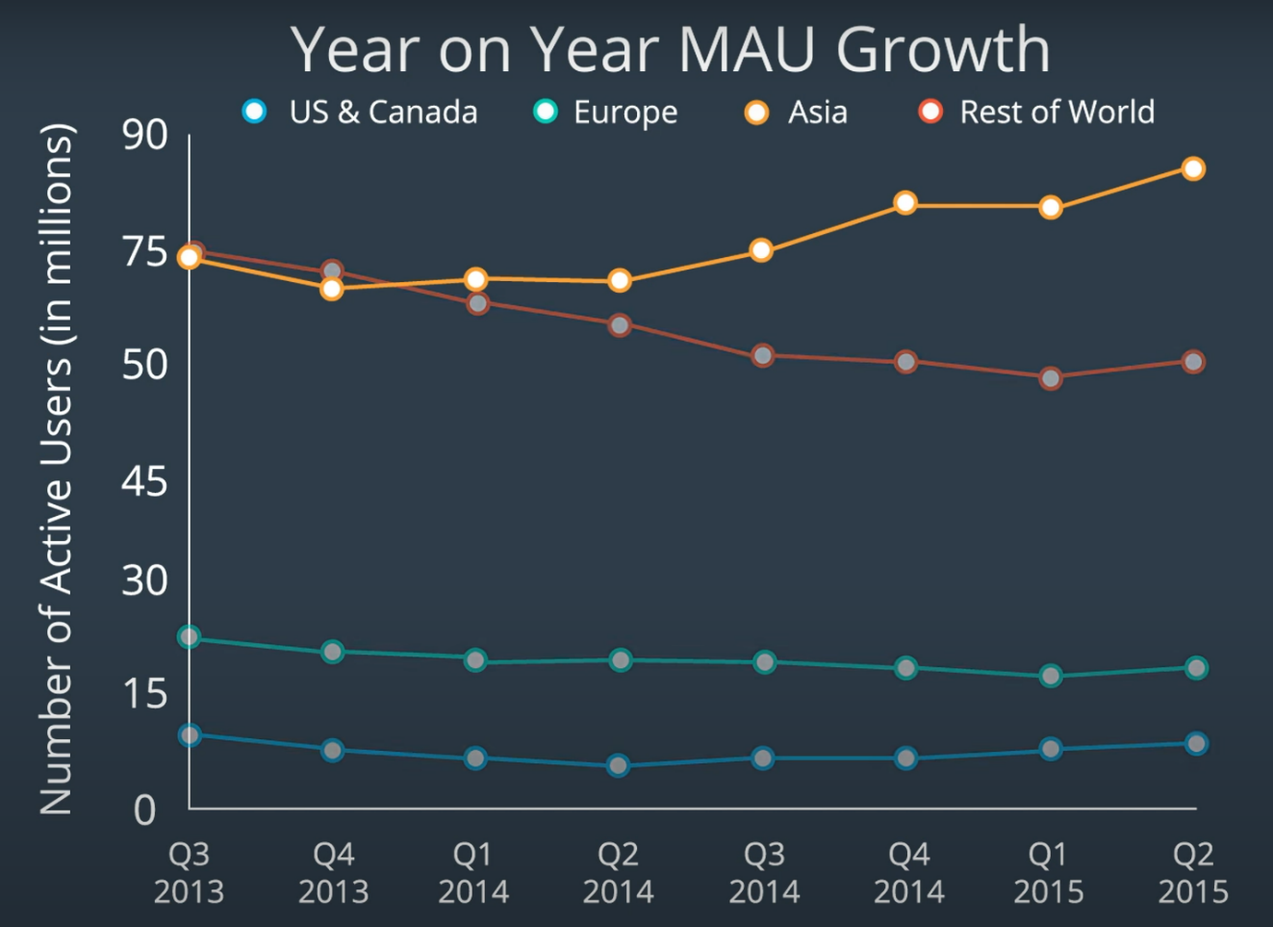

Facebook active user growth chart

This timeline graph shows the year on your monthly active user growth for Facebook across specific world regions between 2013 and '15. On the y-axis is the number of active users in millions. You can see right away how the monthly active user growth in Asia was much higher than for North America and Europe. That meant Facebook users in Asia, we're using the site more frequently and the number was increasing steadily. The line for North America and Europe shows the monthly active user's trend flattening off.

**Recap**

* Engagement metrics are used to define the number of active users within a specific time period (ranging from daily, weekly to monthly).
* **Monthly Active Users:** Number of unique active users in the previous month
* **Daily Active Users:** Number of unique active users the previous day

**Stickiness**

The stickiness ratio is a very useful tool for several stakeholders, such as investors, to know if the website or app has a potential for growth or either on the trajectory, for growth. Essentially, stickiness tells us if the customers are coming back to the website or app every day, or rather, sticking around to actually engage with it.

A DAU by MAU ratio of 0.5 indicates that the average user is engaged or using the app 15 out of 30 days that month.

Common benchmarks for various industries are as follow:

* Social networking site is 0.5
* Gaming apps, it is 0.1 to 0.2
* ...most other apps strive to achieve a stickiness ratio of 0.2

*Why is stickiness important?*It is a useful KPI for management and investors.

Investors want to know if this app or website has the potential to make money in the future. For example, if the plan is to introduce advertising into the app, the potential evaluation will depend on whether the app has many users that keep coming back to it. In other words, they need to know the number of active users will likely increase over time.

**Interpretation of Stickiness Ratio**

* The percentage number means what percent(%) of that months days did the user was online with the site
* A 50% stickiness ratio indicates the average customer used the online app or website 15 of the 30 days in that month. In contrast, a .01 stickiness ratio indicates the average customer used the online app or website < one day that month.

# Churn Rate

**Churn Rate captures the number of people we retain at the end of a time period.**

Let's think about our online grocery delivery store WeCart. If customers don't renew their subscription or request a refund, this impacts our growth. Thus to grow the business, we need to make sure we are retaining the customers we have already acquired. Churn Rate is often adopted by companies using a subscriber-based service model, especially in the telecommunication industry. In recent years, e-commerce and SaaS-based companies have adopted the churn rate metric too.

To calculate the customer churn rate you need 2 simple things:

* Customers at the beginning of usage interval
* Customers at the end of the usage interval

Just looking at these two numbers will tell you whether you end the interval with the same or fewer customers.

**Important note:**We only want to calculate the churn rate based on the customers we started the time interval with. When getting the number of customers at the end of the interval, we do NOT add the customers who converted during the interval. The churn rate should only tell you whether the current customers have left or stayed.

### Calculation

**Customer Churn Rate = (Customers at the beginning of usage interval - Customers at the end of usage interval) / Customers at the beginning of usage interval**

### Terminology

* **Usage Interval:** This time period should make sense for the service or product the customers are using. It can range from a day, a week, to a month or quarter. It depends on the service or product the company is providing and how often you would expect a customer to be active on the website.

For e.g., WeCart is an online grocery business, so we would expect an existing customer to place at least 1 order over a month. We will use the usage interval of 1 month. If the customer has not placed an order over the course of a month, we can count that customer as having churned. Once we have identified these users as having churned, we can focus on the efforts to bring them back to the website and make them active again.

### Interpretation of Churn Rate

While the churn rate is inevitable, in general, an **annual** churn rate of 5% is seen as a reasonable benchmark. Keep in mind that the range for churn rates is wider for B2C companies.

As you calculate your annual churn rate, keep in mind a few other "data assumptions" that you need to watch out for.

1. Select a time interval during which you calculate the churn rate that is consistent with the company's subscription or usage model. There is no ideal usage interval - the usage interval depends on the length of time the company expects the user to be active at least once.
2. Pay attention to different customer segments, especially if they have different churn rates (e.g., by region).
3. Make sure your data does not include new customers gained during the time interval. Churn rate is focusing on customers who stayed or are active vs. stop being active on the website.

**Recap:**

* **Churn Rate** = (Customers beginning of usage interval - Customers end of usage interval) / Customers beginning of usage interval
* Churn rate is a measure of declining growth. Business need to make sure that they are acquiring new customers at a rate faster than their "churn rate"
* Growth rate is a measure of new customers being added in the usage interval.

**New Vocabulary**

* **Software as a service (SaaS)**: SaaS is a software distribution model in which the application is made available on servers hosted by a third-party provider, which in turn provides the software to customers over the Internet.
* **Subscriber-based service model:** Subscriber-based service model is a model where consumers agree to pay a subscription fee to gain access to the service or product.

# Finance Metrics

Now we shift our attention to Finance Metrics.

When you look at the financial metrics, you are focusing on tracking your performance against your company’s financial goal. You are trying to answer the following questions.

* How is your revenue comparing to the costs?
* How are sales trending against sales goals?
* How are sale and marketing lead metrics comparing against acquisitions?

The video above provide you with basic information about financial metrics. There are entire graduate degrees people take to master as part of financial metrics. We have provided some additional information below the videos to give you more information about each metric. But if you find this interesting, you should definitely explore your career options more!

**Items in Profit and Loss Statement**

(*aka income statement*)

The following list is a breakdown of the individual items within the Profit and Loss Statement.

* **Revenues**: The money a company makes from the sales of its products and services.
* **Cost of Goods Sold (COGS) or Cost of Sales**: These are the direct costs the company incurs to develop the product or service being sold.
* **Gross Profit:** The difference between the revenue earned and the costs summarized in COGS. **Gross Profit = Revenue - COGS**
* **Selling, General, and Administrative expenses (SGAs):** Includes the following expenses:
  + Marketing, sale commissions
  + Salaries for office staff
  + Supplies and computer hardware
  + Note: Some companies list total operating expenses separately from SGAS while others treat them as synonymous with SGAS.
* **Operating expenses**: Expenses incurred outside of direct manufacturing costs:
  + Overhead costs
  + Legal
  + Rent
  + Utilities
  + Taxes
  + Interest
  + R&D expenses.
* **Total Operating Expenses** = Sum of SGAs and Operating expenses **Total Operating Expenses= SGAs + Operating Expenses**
* **Operating Income**: The difference between Gross profit and Total operating expenses **Operating Income = Gross Profit - Total Operating Expenses**
  + Note: **Operating Income** is also referred to as **Earnings Before Interest and Tax (EBIT)**
* **Net Income:** Subtracting the Interest and Tax from Operating Income gives the Net Income **Net Income = Operating Income - (Interest and Taxes)**

# Gross Margin

Gross Margin is a statement about the overall profitability of the company.

## Calculation

Gross Margin = (Total Sales Revenue – Cost of Goods Sold) / Total Sales Revenue

which is the same as for Gross Profit / Total Sales Revenue

This metric identifies the revenue that remains after accounting for direct costs of production.

# Contribution Margin

Costs to a company can be split into two major groups;

* **Fixed costs**
  + Fixed costs are expenses that you will incur on a regular, perhaps monthly basis, such as rent, utilities, and employee salaries.
* **Variable costs**
  + Variable costs are expenses that move up and down in response to production output. This interpretation is particularly helpful for companies to determine the pricing of the product.

*In other words, it helps them find the breakeven point where the pricing will cover fixed overhead costs for sure.*

Contribution margin can also be helpful as a useful tool to dive into the P&L statement! While the typical P&L statement line items tell us the overall profitability of our business, contribution margin can be used to identify which product or product line is contributing the most to our profit margin.

(Looking at the graph in the video)

First of all, we want to calculate the overall contribution margin, the difference between the sales revenue and variable cost.

Once you get the difference for the total contribution margin, you divide it by the units sold, and that gives you the contribution margin per unit.

*You can think of the contribution margin as a percentage of your revenue that'll cover your fixed costs, which you have little control over and have to incur.*

* If the contribution margin per unit > fixed cost is your profit.
* If the contribution margin per unit < fixed cost, this means you're making a loss on each sale.

So in other words, if you want to make a profit, you have to sell your product with at least your contribution margin covered for each unit sale.

## Contribution Margin

Contribution Margin tells us the amount of revenue that covers the variable costs and is now available to cover the fixed costs and generate profits. Companies use it to identify which product or product line is contributing the most to the profit margin. It also helps determine the break-even point where the pricing will cover fixed overhead costs and leave enough for profits too.

Fixed costs are also called**sunk costs**. A good caution to keep in mind is that fixed or sunk costs can increase (for e.g., unexpected rent increases, machinery replacement costs), which is why operational managers prefer the term sunk costs. These sunk costs can prove tricky, because a small increment when taken in bulk, can turn out to be catastrophic for companies, especially start-ups.

Citation for the graph depicting [Contribution Margin](https://www.dummies.com/business/operations-management/how-to-prepare-a-cost-volume-profit-analysis/).

In the graph depicted in the video**Total Contribution Margin is indicated by the red line.**

## Terminology

* **Fixed costs:** Expenses incurred on a regular basis, such as monthly rent, utilities, and employee salaries.
* **Variable costs:** Expenses that move up and down in response to production output.
* **Contribution Margin:** The amount of revenue that covers the variable costs and is able to cover the fixed costs.

## Calculation

* **Total Contribution Margin** = Total Sales Revenue - Total Variable Cost
* **Contribution Margin Per Unit:** Total Contribution Margin / Number of Units Sold

#### Topics Covered

1. **Key Performance Indicators:**We will start with a discussion about key performance indicators and how it differs by industries.
2. **Business Process Flow**: Then we will proceed to go through the business process flow across various business divisions. This will provide the context for learning about the business metrics. **Business metric:**We will take on each business area, such as marketing and growth, and introduce you to a metric commonly used to measure success in that business area. We will discuss what each means, and how to calculate it. We will practice calculating the metrics and applying the metrics, and when and where to use the metric. To do this, we will focus on 3 main elements related to metrics:
   * Evaluate important business metrics
   * Interpret and analyze these metrics
   * Create visualizations of these metrics
3. **Distribution and central tendency**: We will circle back to the topic of data distribution that you learned about in the previous lesson, and why paying attention to the distribution of the data and to the choice of measure of central tendency is important.
4. **Grouping data**: We will end with a discussion on how to look at the data across groups, cohorts, and time.

Let's take a moment to summarize the key take-aways from this lesson.

## Overarching Themes Summary

* Businesses use **Key Performance Indicators** to track how they are performing on key goals or objectives.
* The **Marketing Funnel** captures the various stages in the customer's journey. At the top of the funnel, it captures the impressions, clicks, leads, and conversions at the bottom of the funnel.
* **Optimizing the funnel** refers to maximizing the conversion rate at each level of the funnel.
* The **Sales Funnel** captures the various stages in the sales cycle. At the top of the funnel, it captures the prospects, then the leads and qualified leads, and ends with bookings or closed deals at the bottom of the funnel.
* It is important to look at the**distribution of the data** to understand if the measures of central tendency represent a normal distribution. Looking at the distribution and measures of central tendency is a critical step of the data analysis process.
* Data should be examined split across cohorts, business cycles, time, product lines, regions, and other**grouping** criteria to fully understand the data. It is critical to slice the data across various factors to make sense of the data and make recommendations.

#### Metrics

Marketing

* **Click Through Rate (CTR)** is an indication of whether the ad campaign is generating enough interest in potential customers. When the CTR increases, it is an indicator of effective and interesting content in your ad campaign, and that maybe you should increase the number of impressions for that ad.
* **Cost Per Click (CPC)** is an indicator of the cost-effectiveness of the ad platform and a useful tool to compare and strategize about which marketing platform is yielding higher impression and reach and resulting in potential leads.
* **Cost Per Lead (CPL)** is an indicator of the cost-effectiveness of the ad platform and a useful tool to compare and strategize about which marketing platforms yielded more leads.
* **Customer Acquisition Cost (CAC)** is a useful metric used to get an estimate of how much it cost us to acquire the customer in the period the money was spent to reach out to them.

Marketing and Financial

* **Cost Per Acquisition (CPA)** allows a business to gauge whether the marketing campaign is generating enough potential leads.
* **Life Time Value (LTV)** allows you to focus on audiences and potential customers that will generate higher LTVs with minimum customer acquisition cost. There are several ways to calculate the Life Time Value and it is best to calculate the LTV using different ways to arrive at the average LTV for a customer.

Growth

* **Stickiness** indicates whether the customers are staying and returning to the website frequently enough. It is a good measure of the potential growth of the business.
* **Churn rate** is a measure of declining growth and businesses aim to have a higher growth rate than churn rate. It is a measure of whether the business is retaining the acquired customers.

Financial

* The **Profit and Loss Statement** also called an income statement, is one type of financial statement that shows a company's performance and financial position. needed to create the P&L statement are:
* **Revenue** is the money that your company makes from the sales of your products and services
* **Cost of Goods Sold OR Cost of Sales** are the direct costs the company incurs to develop and produce the product or service being sold
* **Gross Profit** is the difference between the revenue and COGS
* **Selling, General, and Administrative expenses** capture a wide range of expenses, from administrative, sales commissions, supplies, legal fees, rent, utilities, taxes, and interests. It is used synonymously with **Operating expenses**. SG&A typically excludes research and development expenses.
* **Operating Profit** is the difference between gross profit and total operating expenses.
* **Net Income** is operating profit minus interest and tax expenses.
* **Gross Margin** tells business executives what percentage of each revenue dollar is available to cover operating expenses after the COGS have been accounted for.
* **Contribution Margin** provides the break-even point where the pricing of a product will cover fixed overhead costs.